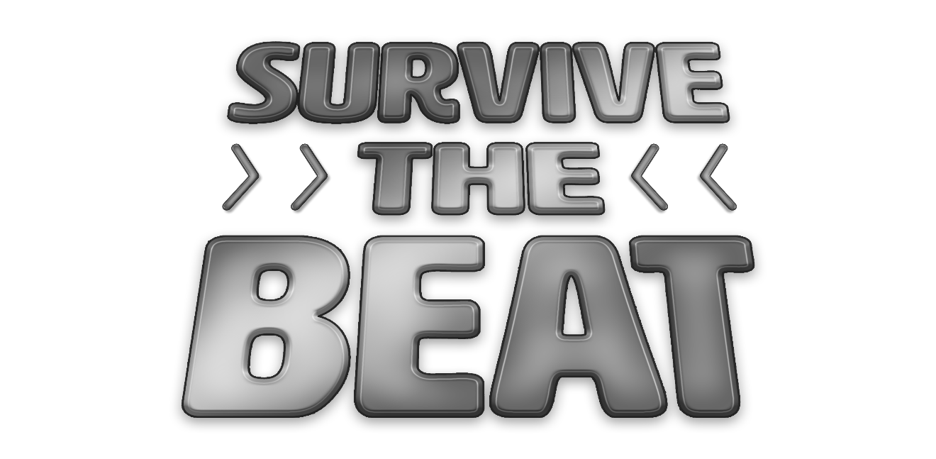

**Design Document for:**

# Survive The Beat

**A First-Person Rhythm Shooter Survival Game**

Created and Directed by Nathan Wisniewski

For Central Michigan University class ITC 383: Computer Game Design

All work unofficially Copyright ©2021 by N.E.W. Multimedia

Written by Nathan Wisniewski

Version # 1.15

Thursday, May 06, 2021

# Table of Contents

Survive The Beat 1

Table of Contents 2

Design History 4

Version 1.00 4

Version 1.01 4

Version 1.02 4

Version 1.03 4

Version 1.04 4

Version 1.05 5

Version 1.06 5

Version 1.07 5

Version 1.08 5

Version 1.09 6

Version 1.10 6

Version 1.11 6

Version 1.12 6

Version 1.13 6

Version 1.14 7

Version 1.15 7

Game Overview 8

High Concept Statement 8

Player’s Role(s) 8

Proposed Primary Gameplay Mode 8

Genre 8

Target Audience 8

Target Platform 8

Competition Modes 8

Progression 8

Game World 8

Competitive Analysis / Inspiration 8

Gradable items: 9

Feature Set 10

General Features 10

Editor 10

Gameplay 10

World Design 11

Initial world concept: 11

Detailed world sketch: 12

List of world objects: Number of objects: 12

Final version of world design: 13

Character Design 14

Overview: 14

About: 14

History: 14

Design: 14

Physical description: 14

Character inhabits: 15

Plot situation / purpose of character: 15

Animations: 15

Influence of character: 16

User Interface 17

Main Game UI Layout: 17

UI Layout Details: 17

Main Game UI Example: 18

Main Menu UI: 18

Flowchart 19

Weapons 20

- **Knife**: 20

- **Pistol**: 20

- **Sub Machine**: 20

- **Tac Rifle**: 20

- **Assault Rifle**: 20

Player 21

Enemies 21

Map 21

Points 21

Rhythm 22

Waves 22

Unimplemented Work 22

Credits 23

# Design History

## Version 1.00

Initial game world design.

* Created terrain.
* Imported assets from Asset Store that will be used for the project.
* Painted terrain with textures.
* Planned placements for spawns, doors, and objects.

## Version 1.01

Additional work of world design.

* Recreated terrain with more reasonable object sizes.
* Added player controller prefab.
* Added zombie prefab.
* Added skybox.

## Version 1.02

Implementation of spawns. More definition of areas.

* Created 14 spawns for enemies.
* Created 6 doors.
* Created enemy spawn script.
* Some minor world touch-ups.

## Version 1.03

Defined Out-Of-Bounds. More work on spawns with NavMesh.

* Added invisible object colliders that limit players to not go OOB.
* Enemies now only spawn at points where areas are unlocked/opened.
* NavMesh created.
* Enemies now track player’s movements, move towards player.
* Single wave of enemies created.

## Version 1.04

Weapons implementation. Work on wave system.

* Added 3 weapons, including pistol, sub, and assault.
* All weapons are currently single shot.
* Weapon signs/pickup locations created.
* Full wave system implemented. Enemies now spawn in waves.
* Each wave increases number of enemies that spawn in a given wave.
* Currently set to be unlimited number of waves.

## Version 1.05

Additional work to weapons.

* Added 2 weapons, including knife and tac.
* Created individual scripts for each 5 weapons.
* Each weapon has ammo counts. The overall ammo is unlimited, but players must reload frequently.
* Pistol has 8 shots per clip.
* Sub has 16 shots per clip.
* Tac has 24 shots per clip.
* Assault has 32 shots per clip.
* Created shot and reload animations for pistol, sub, and assault.
* Pistol and knife are single shot.
* Sub is double shot.
* Tac is triple shot.
* Assault is quadruple shot.

## Version 1.06

Implementation of enemy health system and weapon damages.

* Each enemy has their own health integers.
* Added damage values to each weapon.
* Each weapon deals 1 damage per shot.
* Each enemy has 1 health point.
* Enemies despawn upon death.

## Version 1.07

Implementation of points system.

* Created points system layout.
* Each kill is 100 points.
* Added buyable and cost values to doors and weapons.
* Pistol costs 500 points.
* Sub costs 1000 points.
* Tac costs 1500 points.
* Assault costs 2500 points.
* First doors costs 750 points.
* Second doors costs 1250 points.
* Third doors costs 1500 points.

## Version 1.08

Implementation of rhythm system.

* First version of rhythm system created.
* Created indicator assets.
* Created animations for indicators.
* Added UI of rhythm indicators.
* Created first tempo.
* Set timing window for shots.

## Version 1.09

Enemy work, including animations.

* Created run animation for enemies.
* Created death animation for enemies.
* Enemies now play animations when spawned.
* Enemies now play animations when dying.
* Enemies now despawn 6 seconds after death animation plays.
* Added some light red fog to game world.

## Version 1.10

Additional work of rhythm system.

* Added 2 tempos.
* Adjusted timing window.
* Adjusted animations for indicators.
* Fixed some initial bugs with the display of rhythm system.
* Added audio source.
* Added multiple audio background tracks, from the YouTube Audio Library.
* Added background tracks to each tempo.
* Added gun shot sound to weapons.
* Added bullet impact hit visual effect.

## Version 1.11

Implementation of player health system.

* Player health system created. Player has 100 hit points.
* Enemies deal 10 hit points per collision.
* Added delay to each hit from enemy, that way enemies do not instantly down player.
* When player reaches 0 hit points, movement script is disabled.
* Some minor adjustments to enemy health system.
* Some minor adjustments to wave system.

## Version 1.12

Implementing the main menu.

* Created main menu scene.
* Created game logo.
* Created game icon.
* Created settings scene. Only displays controls.
* Created credits scene. Displays assets used from Asset Store and audio used from YouTube Audio Library.
* Added Play, Settings, Credits, and Quit buttons to menu.
* Added logo and some visual indicators to menu.

## Version 1.13

Main UI implementation.

* Added UI elements during gameplay.
* Display wave number in lower-left.
* Display points available in upper-left.
* Display player’s health values in upper-right.
* Display weapon’s ammo count in lower-right.
* Display buy cost pop-up message underneath rhythm indicators, if players are near a buyable door or weapon.
* Players can only buy if they have enough points.
* Some bug fixes to points system.

## Version 1.14

Overall gameplay adjustments.

* Players now only deal damage on good shots.
* Players still shoot ammo on either good shots or bad shots.
* Players now receive 10 points for each good shot.
* Weapons do not produce bullet hit visual effect on bad shots, only for good shots.
* Added shot and reload animations to tac weapon.
* Added swing animation to knife.
* Added details and trees to game world. Mainly OOB visuals.
* Adjusted some scripts, including health scripts, wave scripts, point scripts, and rhythm system.
* Some major bug fixes to rhythm system.

## Version 1.15

Last implementation before submission. Added game-ending UI. Work on settings. Last-minute adjustments and fixes.

* Added UI elements for when player dies.
* Hide other UI elements when player dies.
* Added function to count each kill by player.
* Game-ending UI displays the wave number the player reached.
* Game-ending UI displays how many kills the player achieved.
* The game goes to menu 5 seconds after player dies.
* Adjusted values.
* Sub now has 24 shots per clip.
* Tac now has 36 shots per clip.
* Assault now has 64 shots per clip.
* Sliders added to settings menu.
* Players can now adjust what wave to start from. Values range from wave 1 to wave 10.
* Players can now adjust how much points to start with. Values increment by 500s, ranging from 0 to 10,000.
* Some major bug fixes to rhythm system.
* Some minor bug fixes to weapons.
* Some major bug fixes to points system.
* Some minor bug fixes to health systems.
* Project built for submission.

# Game Overview

## High Concept Statement

“Survive The Beat” is a rhythm first-person shooter game where players must keep up with the beat while

surviving against waves of enemies. Players can only shoot or interact with the tempo of the music. The

objective is to survive…

## Player’s Role(s)

The player will play as a role of a soldier to investigate an area and eliminate any threats.

## Proposed Primary Gameplay Mode

The primary gameplay mode will be Survival Mode, where the player must survival any attacks and

eliminate the threats. Players can acquire multiple weapons throughout the map. Players can only shoot

and interact on the beats of the background music. Players will view the game in a first-person

perspective.

## Genre

A first-person shooter with some rhythm elements.

## Target Audience

The target audience is those who like rhythm games and first-person shooter games. The expected rating

would most likely be rated M for blood and violence. Instead of typical first-person shooter games, this

game incorporates a rhythm aspect.

## Target Platform

The game will be developed for Windows PC only at this time.

## Competition Modes

Currently, the game will only support single player.

## Progression

The game will be only based on a single large-scaled map. In the beginning of each match, the players will

only have access to a small portion of the map. The players can earn points to purchase different weapons

or unlock additional areas of the map. Enemies start off weak, yet after each round, more enemies spawn

and enemies get tougher.

## Game World

A large-scaled map, with multiple sections that can be unlocked with accumulated points.

## Competitive Analysis / Inspiration

Multiple competitors that this game inspires from. This game attempts to combine each game into one.

- Call of Duty franchise (Zombies modes): Survival aspects.

- Guitar Hero/Rock Band: Rhythm aspects.

- Crypt of the Necrodancer: Dungeon, overhead-perspective, rhythm, hack-and-slash game.

- BPM: Bullets Per Minute: Dungeon, first-person, rhythm, linear adventure game.

## Gradable items:

1. Aesthetics: Harmony, Immersion, Emotional Resonance.

2. Excel in programming and modeling.

3. More complex than the final project from CPS 382.

4. Project that starts and ends correctly.

5. Substance: At least ten minutes of unique game play.

6. Implementing various unique weapons. (At least three weapons.)

7. Implementing an unique interaction system using rhythm aspects with various tempos. (At least

three tempos.)

8. Implementing an enemy AI spawn system in waves. (At least ten wave settings.)

9. Create a large scale map terrain with details, including trees and other objects.

10. Create a main menu for players that allows players to change some settings

# Feature Set

## General Features

Large-scaled world, with multiple areas.

Multiple background tempos and tracks.

Multiple weapons.

Rhythm system.

Points system.

Wave system.

Health system.

## Editor

Unity terrain tools to create the game world, and ProTools to create the out-of-bounds..

## Gameplay

First person shooter survival gameplay, with a rhythm interaction system.

Enemies come in waves.

Players earn points by getting good shots and getting kills.

Players must survive for as long as possible, while eliminating as much enemies as possible.

# World Design

World Name: Musikland der Toten (German translation – Music Land of the Dead)

## Initial world concept:

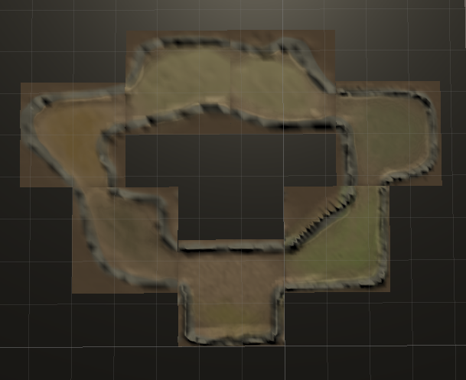

## Detailed world sketch:

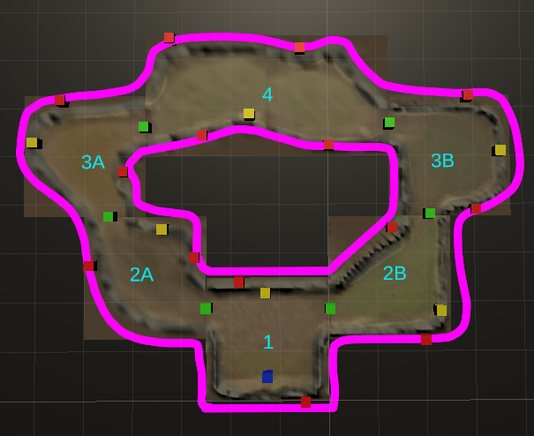

## List of world objects: Number of objects:

* Blue: Player spawn/start point 1
* Green: Gates/Doors between areas 6
* Red: Enemy spawn points 14
* Yellow: Weapon buyables 6
* Pink outline: Player Area boundaries 2
* Cyan text: Area identifiers 6

## Final version of world design:

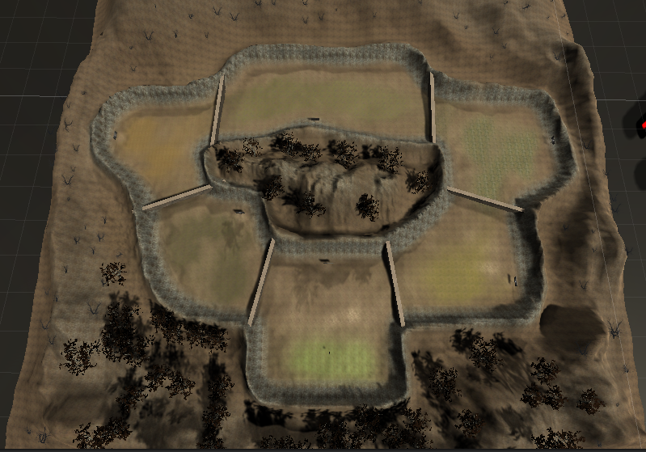

# Character Design

Character name:

* Common zombie enemy

## Overview:

* Zombies are a common enemy that the player must eliminate to progress through the game.

## About:

* The common enemy the player will have to eliminate. The zombies attack the player in groups. The groups increase in size after each wave, as well as the enemies get tougher to defeat.

## History:

* Each zombie has their own story. Typically locals from the area that had a normal, happy life. Before death, each zombie worked at a job, bought a house and car, raised a family, and retired. Yet a mysterious substance in the air awoken the dead. Now the dead became the undead, and arise from their six-foot holes to cause havoc in the area. It is up to the player to eliminate the awoken undead before things get worse.

## Design:

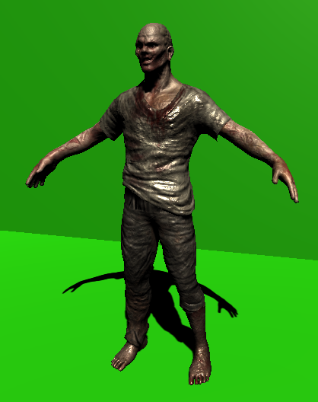

* Modern Zombie Free.
* From the Unity Asset Store.
* Asset made by Artalasky.

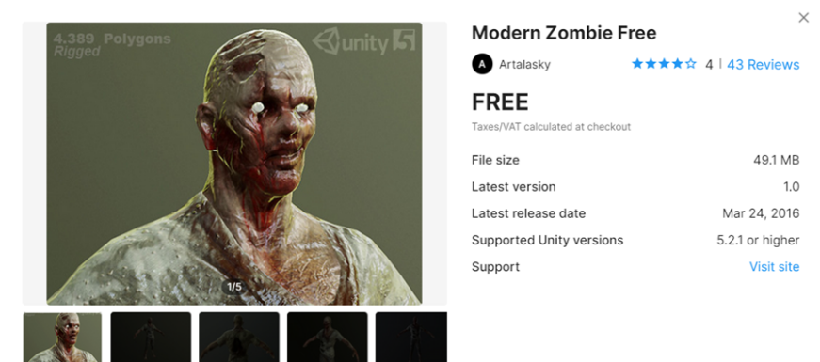

## Physical description:

* Gender: Males
* Age: Varies
* Height: 6 feet (average)
* Weight: 120 lbs (average)
* Physique: Weak, undead
* Eye color: Varies
* Abilities: Swing arms for attacking, multiple run speeds
* Clothes: Dirty and ragged shirt and pants, no shoes
* Looks: Undead

## Character inhabits:

* Dark, gloomy areas.
* All enemies are undead.
* Does not sleep, but more aggressive at nights.
* No food or water resources required to stay “alive”.
* Likes to snack on brains and flesh.

## Plot situation / purpose of character:

* Common enemy that invades the area the player explores. The objective is the same between every enemy, which is to kill the player at any costs. The enemies will attack in groups, which the groups get larger in size after each wave is completed. The enemies only have one melee weapon, which is their arms.

## Animations:

* 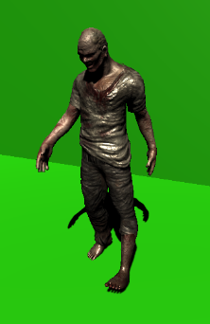Walk animation.
  + - * The normal walking pace for the enemy.
      * Walks one leg step at a time, with stutter.
      * Head slightly pointed downwards.
      * Arms staying low, to sides.
* 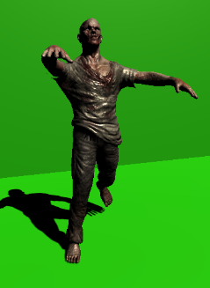Run animation.
  + - * The fastest walking pace for the enemy.
      * Runs with both legs moving.
      * Head slightly bobbing upwards.
      * Arms flailing outwards.

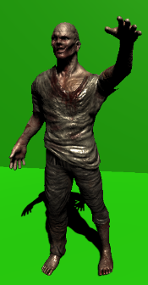

* Attack animation.
  + - * The attacking motion when attempting to deal damage to the player.
      * Legs standing still.
      * Head looking straight at player.
      * Swings left arm first, then right arm.

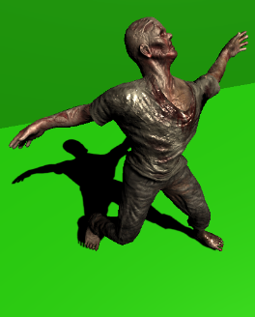

* Death animation.
  + - * When the enemy runs out of health, fall over and die.
      * Twisting motion.
      * Lay flat on ground after animation completes.

## Influence of character:

* Typical enemy from multiple games featuring wave survival modes, like Call of Duty’s Zombies modes. Not really a very unique character overall in compared to normal zombie games. One unique feature that will be different from the typical zombie is the eye color between each zombie will differentiate, which the eye color will describe how tough the enemy is.

# User Interface

## Main Game UI Layout:

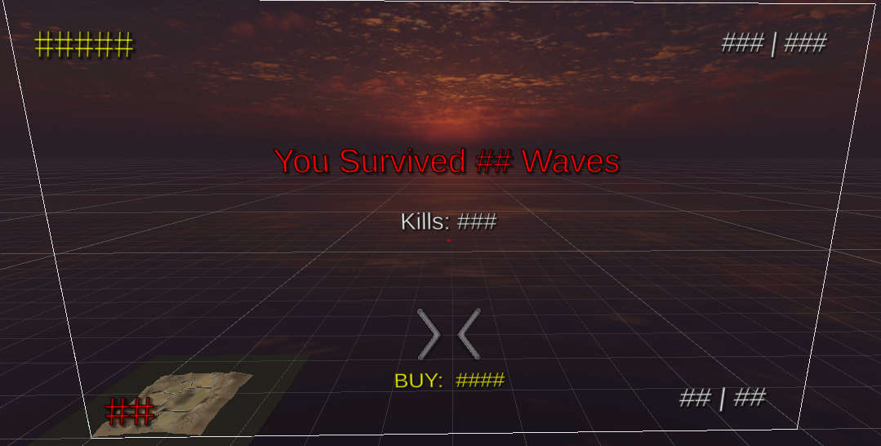

## UI Layout Details:

* Upper-Left: Points count.
* Upper-Right: Player health.
* Lower-Left: Wave number.
* Lower-Right: Ammo count.
* Full screen middle: Rhythm interaction indicators.
  + Center: Gery.
  + Shots: Yellow.
  + Green: Good shot.
  + Red: Bad shot.
* Lower-middle: Cost of item.
* Upper-middle: (Only displays on death) Final wave count.
* Middle: (Only displays on death) Total number of kills.

## Main Game UI Example:

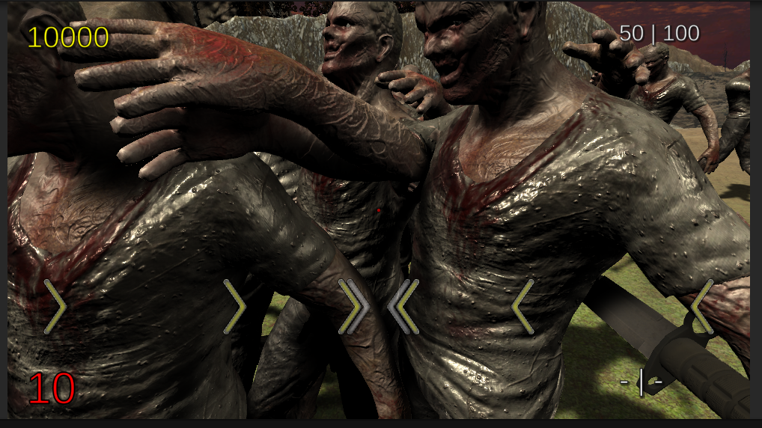

## Main Menu UI:

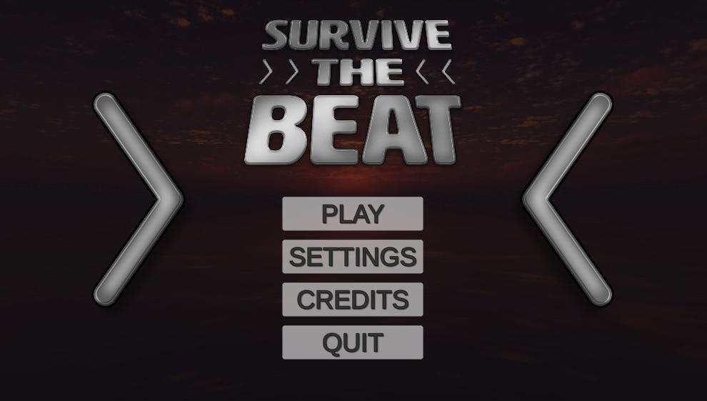

# Flowchart

## - Number of waves completed

out of 10.

Fade out, 5 seconds

Fade in

Fade in

Fade in

Fade in

~10 second load

Fade in

Fade in

Fade in

Restart game,

to Main Menu.

Primary Gameplay Mode

Display Total

Kill Count Stats

“You Survived

10 Waves”

“You Survived

## Waves”

Survived

“You Escaped”

Death

“You Died”

Conclusion

Results Screen

Loading Screen

Map Layout

Main

Menu

Settings

Menu

# Weapons

* **Knife**:
  + Base Damage: 1 hit-point.
  + Location: Starter.
  + Ammo: Unlimited.
  + Shot type: Single.
  + Cost: N/A.
* **Pistol**:
  + Base Damage: 2 hit-points.
  + Location: 1.
  + Ammo: 8 bullets per clip.
  + Shot type: Single.
  + Cost: 500 points.
* **Sub Machine**:
  + Base Damage: 3 hit-points.
  + Location: 2A, 3B.
  + Ammo: 24 bullets per clip.
  + Shot type: Two.
  + Cost: 1000 points.
* **Tac Rifle**:
  + Base Damage: 3 hit-points.
  + Location: 2B, 3A.
  + Ammo: 36 bullets per clip.
  + Shot type: Three.
  + Cost: 1500 points.
* **Assault Rifle**:
  + Base Damage: 4 hit-points.
  + Location: 4.
  + Ammo: 64 bullets per clip.
  + Shot type: Four.
  + Cost: 2500 points.

# Player

* Health: 100 hit-points maximum.
* Healing: Automatically to full health once a wave ends.
* Lives: One single life. No revives.

# Enemies

* Damage: 10 hit-points
* Health: 8 hit-points * Wave number.
  + Ex: On Wave 2, the enemies will have 16 HP. On Wave 10, 80 HP.
* Group sizes: 8 enemies * Wave number.
  + Ex: On Wave 3, the player must kill 24 enemies. On Wave 10, 80 enemies must be eliminated.
* Weapons: Fists only. No guns.

# Map

* 6 areas.
  + 1: 1 Player spawn, 2 doors, 2 enemy spawns, 1 weapon.
  + 2A / 2B: 2 doors, 2 enemy spawns, 1 weapon.
  + 3A / 3B: 2 doors, 2 enemy spawns, 1 weapon.
  + 4: 2 doors, 4 enemy spawns, 1 weapon.
* 2 pathways.
  + 1 > 2A > 3A > 4.
  + 1 > 2B > 3B > 4.
* Circular layout.
* Door costs:
  + 1 > 2A / 2B: 750 points.
  + 2A / 2B > 3A / 3B: 1250 points.
  + 3A / 3B > 4: 1500 points.

# Points

* Starting amount: 500 points.
  + Can be changed in Settings.
* Per hit: 10 points.
  + Bonus 40 points if Player hits perfect measure.
* Per kill: 50 points.
  + Bonus 50 points if headshot.
* See Map for door costs.
* See Weapons for weapon costs.

# Rhythm

* Three unique background tracks.
  + 120 Beats Per Minute.
  + 160 BPM.
  + 200 BPM.
* Track changes after each wave.
* Deal damage when Player clicks on each beat.
* Will always be 4 beats per measure.
* Gun may misfire and deal no damage if Player is off-beat.

# Waves

* 10 Waves in total.
* If Player completes all 10 Waves, a Final Wave Escape Wave occurs.
* Enemies get more health and damage.
  + See Enemies for more information and values.
* Player recovers all health after each Wave completion.

# Unimplemented Work

Not everything was implemented from the initial concept works. After submission, the following features can be implemented in future versions:

* Add final wave / ending resulting in a win.
* Have enemies become stronger health-wise after each wave.
* Properly adjust tempos in rhythm system.
* Add damage to bad shots, but very weak damage dealt.
* Adjust health and damage values of weapons and enemies.
* Add higher bonus for good shots.
* Each enemy hit is rewarded points.
* Add bonus for headshots.
* Add unique weapon shot sounds.
* Add more tracks and tempos.
* Add more settings, including changeable controls.
* Add fade-in and fade-out transitions/animations.
* Add more enemy speeds, different between walk and run.
* Add enemy spawn animation.
* Add mini-map.
* Do more adjustments and touch-ups.
* Fix major bugs!

# Credits

**ASSETS**

- Standard Assets by Unity Technologies

- Terrain Tools by Unity Technologies

- MicroSplat by Jason Booth

- AllSky Free by rpgwhitelock

- Yughues Free Ground Materials by Noblax

- Yughues Free Metal Materials by Noblax

- Outdoor Ground Textures by A Dog's Life Software

- Birth Tree Pack vol. 1 by Works For Fun

- Modern Weapons Pack by 7XF Design

- 1911 Pistol Pack by Perfect Games

- M9 Knife by Urbanity

- Cartoon FX Free by Jean Moreno

- Modern Zombie Free by Artalasky

**AUDIO**

Weapon Sound Effects are from freesound.org

Background tracks are from the YouTube Audio Library

- Higher Octane by Vans In Japan

- Chtulthu by Quincas Moreira

- Twin Engines by Jeremy Korpas